**Web API Improvements in .Net 5**

**Notes:-**

**1-in .net 5 its support for the Open API option which set easy way to identify swagger in simple way**

**Steps:-**

**1-make sure that you choose Asp.Net Core 5.0 and Enable OpenAPI support**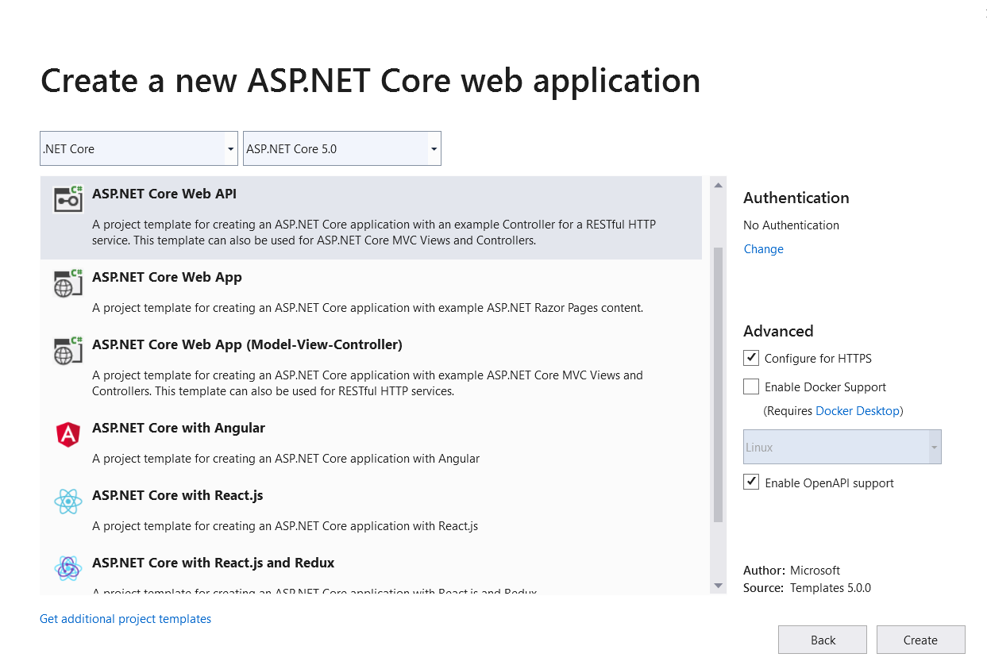

**2-you will see that the configuration are set by default for the swagger that support multiple versions of web API as below.**

**//we will see that it will configured by default in the startup.cs class**

**public class Startup{**

**public Startup(IConfiguration configuration){Configuration = configuration;}**

**public IConfiguration Configuration { get; }**

**// This method gets called by the runtime. Use this method to add services to the container.**

**public void ConfigureServices(IServiceCollection services){**

**services.AddControllers();**

**services.AddSwaggerGen(c =>{**

**c.SwaggerDoc("v1", new OpenApiInfo { Title = "Net5API", Version = "v1" });});}**

**// This method gets called by the runtime. Use this method to configure the HTTP request pipeline.**

**public void Configure(IApplicationBuilder app, IWebHostEnvironment env){**

**if (env.IsDevelopment()){**

**app.UseDeveloperExceptionPage();**

**app.UseSwagger();**

**app.UseSwaggerUI(c => c.SwaggerEndpoint("/swagger/v1/swagger.json", "Net5API v1"));}**

**app.UseHttpsRedirection();**

**app.UseRouting();**

**app.UseAuthorization();**

**app.UseEndpoints(endpoints =>{endpoints.MapControllers();});}}**

**3-run the application and you see that redirect to swagger by default as below**

**https://localhost:44360/swagger/index.html**

**Swagger is an open API documentation and with interactive UI with web API controllers**

**4-With the Open API we can take the open API schema and save it in the target project and then on connected service 🡪 right click 🡪 add connected service**

**And choose the file the represent the swagger schema**

**Or choose the swagger api url that get the schema**

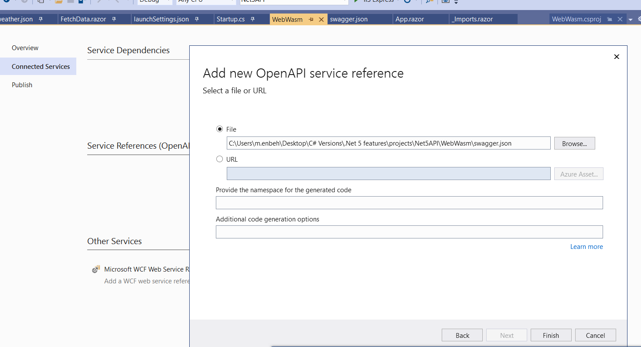

**5-in the web assembly we remove the base URL as below**

**public class Program{**

**public static async Task Main(string[] args){**

**var builder = WebAssemblyHostBuilder.CreateDefault(args);**

**builder.RootComponents.Add<App>("#app");**

**//we remove the base URL**

**builder.Services.AddScoped(sp => new HttpClient());**

**await builder.Build().RunAsync();}}**

**6-in the FetchData.razor we set the following code**

**@code {**

**private ICollection<WeatherForecast> forecasts;**

**protected override async Task OnInitializedAsync(){**

**SampleSwaggerClient client = new("https://localhost:44360/", Http);**

**forecasts = await client.WeatherForecastAsync();**

**// forecasts = await Http.GetFromJsonAsync<WeatherForecast[]>("sample-data/weather.json");}}**

**7-in the web api > startup.cs we set the CORS policy access origin to accept the url of the web assembly as below**

**using Microsoft.AspNetCore.Builder;**

**using Microsoft.AspNetCore.Hosting;**

**using Microsoft.AspNetCore.HttpsPolicy;**

**using Microsoft.AspNetCore.Mvc;**

**using Microsoft.Extensions.Configuration;**

**using Microsoft.Extensions.DependencyInjection;**

**using Microsoft.Extensions.Hosting;**

**using Microsoft.Extensions.Logging;**

**using Microsoft.OpenApi.Models;**

**using System;**

**using System.Collections.Generic;**

**using System.Linq;**

**using System.Threading.Tasks;**

**namespace Net5API{**

**public class Startup{**

**public Startup(IConfiguration configuration){Configuration = configuration;}**

**public IConfiguration Configuration { get; }**

**// This method gets called by the runtime. Use this method to add services to the container.**

**public void ConfigureServices(IServiceCollection services){**

**//we add cros policy origin as below**

**services.AddCors(**

**options =>{**

**options.AddPolicy(name: "WebWsm", builder =>{**

**builder.WithOrigins("https://localhost:44321", "https://localhost:5001").WithMethods("Get", "POST", "DELETE");});});**

**services.AddControllers();**

**services.AddSwaggerGen(c =>{**

**c.SwaggerDoc("v1", new OpenApiInfo { Title = "Net5API", Version = "v1" });});}**

**// This method gets called by the runtime. Use this method to configure the HTTP request pipeline.**

**public void Configure(IApplicationBuilder app, IWebHostEnvironment env){**

**if (env.IsDevelopment()){**

**app.UseDeveloperExceptionPage();**

**app.UseSwagger();**

**app.UseSwaggerUI(c => c.SwaggerEndpoint("/swagger/v1/swagger.json", "Net5API v1"));}**

**app.UseHttpsRedirection();**

**//we use the cros policy origin**

**app.UseCors("WebWsm");**

**app.UseRouting();**

**app.UseAuthorization();**

**app.UseEndpoints(endpoints =>{endpoints.MapControllers();});}}}**